Constantino’s Market at University Circle
1st Annual Clambake 2012

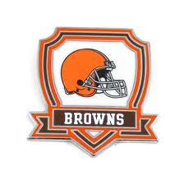
Come Join Constantino’s Market for Our First Annual Clambake
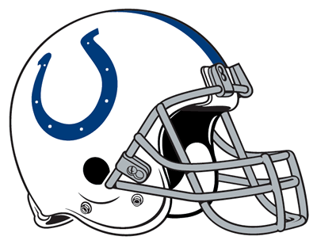
& watch the Brown’s game with Us!

What’s Happening:
Enjoy an amazing Clambake prepared by
Chef Michael Fadel & watch
BROWN’S versus the INDIANAPOLIS COLTS
On our 50” High Definition TVs

Where:
See & Be Seen at Constantino’s Market in University Circle located at
11473 Euclid Avenue, Cleveland, Ohio 44106
In our Uptown Café

When:
October 21st, 2012 starting at 12:00 pm
Game Time: 1:00 pm.

How To:
Find out more through the catering office at 216.721.6000 ext. 223 or email at Theresa@constantinosmarket.com
Seats are limited by purchase and specific seating arrangements are not reserved, so come early to grab your ideal seat!
Purchase in store. Campus One Card Accepted.

Buy VIP!!!
Reserve our Board room for you and 10 of your friends!
Enjoy the game and a delicious Clambake while relaxing plush office chairs!
Additional charge of 3$ per person.

What’s on the Menu?
A Traditional Clambake
Includes two beverages your choice between Alcoholic for $26 or NON Alcoholic for $23.50
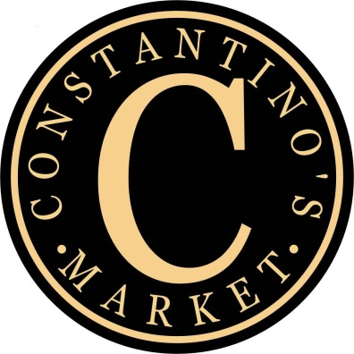
Why change it when it’s already perfect?
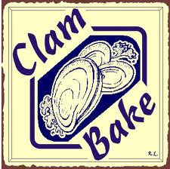
Cup of Clam Chowder
1 dozen Steamed Clams
½ Chicken
Ear of Corn & Potatoes

Pre-purchase clams by the dozen!

Identification is necessary if purchasing the alcoholic beverage package at the time of purchase and when redeeming day of event.

